Chapter 1

**INTRODUCTION**

**INTRODUCTION :-**

FUEL consumption models for vehicles are of interest to manufacturers, regulators, and consumers. They are needed across all the phases of the vehicle life-cycle. we focus on modeling average fuel consumption for heavy vehicles during the operation and maintenance phase. In general, techniques used to develop models for fuel consumption fall under three main categories:

## Physics-based models:-which are derived from an in-depth understanding of the physical system. These models describe the dynamics of the components of the vehicle

## Machine learning models:- which are data-driven and represent an abstract mapping from an input space consisting of a selected set of predictors to an output space that represents the target output.

## Statistical models:- which are also data-driven and establish a mapping between the probability distribution of a selected set of predictors and the target outcome.

## a model that can be easily developed for individual heavy vehicles in a large fleet is proposed.

## Relying on accurate models of all of the vehicles in a fleet, a fleet manager can optimize the route planning for all of the vehicles based on each unique vehicle predicted fuel consumption thereby ensuring the route assignments are aligned to minimize overall fleet fuel consumption.

## These types of fleets exist in various sectors including, road transportation of goods , public transportation , construction trucks and refuse trucks .

## For each fleet, the methodology must apply and adapt to many different vehicle technologies (including future ones) and configurations without detailed knowledge of the vehicles specific physical characteristics and measurements.

Chapter 2

**ABSTRACT**

we used vehicle travel distance rather than the traditional time period when developing individualized machine learning models for fuel consumption. This approach is used in conjunction with seven predictors derived from vehicle speed and road grade to produce a highly predictive neural network model for average fuel consumption in heavy vehicles. The proposed model can easily be developed and deployed for each individual vehicle in a fleet in order to optimize fuel consumption over the entire fleet. The predictors of the model are aggregated over fixed window sizes of distance travelled. Different window sizes are evaluated and the results show that a 1 km window is able to predict fuel consumption with a 0.91 coefficient of determination and mean absolute peak-to-peak percent error less than 4% for routes that include both city and highway duty cycle segments.

**EXISTING SYSTEM :-**

model that can be easily developed for individual heavy vehicles in a large fleet is proposed. Relying on accurate models of all of the vehicles in a fleet, a fleet manager can optimize the route planning for all of the vehicles based on each unique vehicle predicted fuel consumption thereby ensuring the route assignments are aligned to minimize overall fleet fuel consumption.

This approach is used in conjunction with seven predictors derived from vehicle speed and road grade to produce a highly predictive neural network model for average fuel consumption in heavy vehicles.

Different window sizes are evaluated and the results show that a 1 km window is able to predict fuel consumption with a 0.91 coefficient of determination and mean absolute peak-to-peak percent error less than 4% for routes that include both city and highway duty cycle segments.

**Disadvantages of existing system:**

Physics-based models, which are derived from an in-depth understanding of the physical system. These models describe the dynamics of the components of the vehicle each time step using detailed mathematical equations.

Statistical models, which are also data-driven and establish a mapping between the probability distribution of a selected set of predictors and the target outcome.

**PROPOSED SYSTEM :-**

As mentioned above Artificial Neural Networks (ANN) are often used to develop digital models for complex systems.The models proposed in [15] highlight some of the difficulties faced by machine learning models when the input and output have different domains. In this study, the input is aggregated in the time domain over 10 minutes intervals and the output is fuel consumption over the distance traveled during the same time period.The complex system is represented by a transfer function F(p) = o, where F(·) represents the system, p refers to the input predictors and o is the response of the system or the output. The ANNs used in this paper are Feed Forward Neural Networks (FNN).

Training is an iterative process and can be performed using multiple approaches including particle swarm optimization [20] and back propagation.Other approaches will be considered in future work in order to evaluation their ability to improve the model’s predictive accuracy.Each iteration in the training selects a pair of (input, output) features from Ftr at random and updates the weights in the network. This is done by calculating the error between the actual output value and the value predicted by the model

**ADVANTAGES OF PROPOSED SYSTEM:**

# Data is collected at a rate that is proportional to its impact on the outcome. When the input space is sampled with respect to time, the amount of data collected from a vehicle at a stop is the same as the amount of data collected when the vehicle is moving.

# The predictors in the model are able to capture the impact of both the duty cycle and the environment on the average fuel consumption of the vehicle (e.g., the number of stops in an urban traffic over a given distance).

# Data from raw sensors can be aggregated on-board into few predictors with lower storage and transmission bandwidth requirements. Given the increase in computational capabilities of new vehicles, data summarization is best performed on-board near the source of the data.

**SOFTWARE REQUIREMENT SPECIFICATION**

**User Requirements**

Requirement Specification plays an important role to create quality software solution. Requirements are refined and analysed to assess the clarity. Requirements are represented in a manner that ultimately leads to successful software implementation.

**Software Requirements**

The software requirements specification is produced at the end of the analysis task. Software requirement is a difficult task, For developing the Application

1. Python

2. Technologies and Languages used to Develop

-- Python

**Hardware Requirements**

This is an project so hardware plays an important role. Selection of hardware also plays an important role in existence and performance of any software. The size and capacity are main requirements.

* Operating System supported by

1. Windows 7

2. Windows XP

3 . Windows 8

* Processor – Pentium IV or higher
* RAM -- 256 MB
* Space on Hard Disk -- Minimum 512 MB

**Module Description:-**

## **Upload Heavy Vehicles Fuel Dataset :-**

Using this module we can upload train dataset to application. Dataset contains comma separated values.

**Read Dataset & Generate Model:-**

Using this module we will parse comma separated dataset and then generate train and test model for ANN from that dataset values. Dataset will be divided into 80% and 20% format, 80% will be used to train ANN model and 20% will be used to test ANN model.

**Run ANN Algorithm:** Using this model we can create ANN object and then feed train and test data to build ANN model.

**Predict Average Fuel Consumption:** Using this module we will upload new test data and then ANN will apply train model on that test data to predict average fuel consumption for that test records.

**Fuel Consumption Graph:** Using this module we will plot fuel consumption graph for each test record.

Chapter 4

**DESIGN**

**INTRODUCTION**

Software design sites at the technical kernel of the software engineering process and is applied regardless of the development paradigm and the area of application. Design is the first step in the development phase for any engineered product or system. The designer’s goal is to produce a model or representation of an entity that will later be built. Beginning, once system requirements have been specified and analysed, system design is the first of the three technical activities – design, code and test that is required to build and verify software.

During design, progressive refinement of data structure, program structure and procedural details are developed, reviewed and documented. System design can be viewed from either technical or project management perspective. From the technical point of view, design is comprised of four activities – architectural design, data structure design, interface design, procedural design.

**Feasibility Study**

Feasibility study is accompanied once the difficult is obviously understood. The feasibility study which is a great level lozenge version of the whole system analysis and design procedure. The independent is to define whether the planned system is possible or not and it benefits us to the least expense of how to resolve the problem and to govern, if the Problem is wealth solving.

The following are the three important tests that have been conceded out for feasibility Study.

* Technical Feasibility
* Economic feasibility
* Operational feasibility

**TECHNICAL FEASIBILITY**

In the technical feasibility study, one has to assess whether the implemented system can be established using existing technology or not. It is intended to implement the implemented system in JSP. The project enabled is theoretically feasible since the following reasons.

* All needed technology exists to improve the system.
* The existing system is so malleable that it can be advanced further.

**ECONOMIC FEASIBILITY**

As a portion of this, the expenses and profits related with the implemented systems are to be associated. The project is carefully feasible only if tangible and intangible assistances balance the cost. We can say the implemented system is feasible founded on the following grounds.

* The charge of developing the filled system is sensible.
* The cost of hardware and software for the application is less.

**OPERATIONAL FEASIBILITY**

This project is operationally feasible for there is necessary support from the project organization and the users of the implemented system .Implemented system absolutely does not damage and determination not create the corrupt results and no problem will ascend after implementation of the system.

**User-friendly**

Customer will use the forms for their various transactions i.e. for adding new routes, viewing the routes details. Also the Customer wants the reports to view the various transactions based on the constraints. These forms and reports are generated as user-friendly to the Client.

**Reliability**

The package wills pick-up current transactions on line. Regarding the old transactions, User will enter them in to the system.

**Security**

The web server and database server should be protected from hacking, virus etc.

**UML DIAGRAM’S**

**CLASS DIAGRAMS**

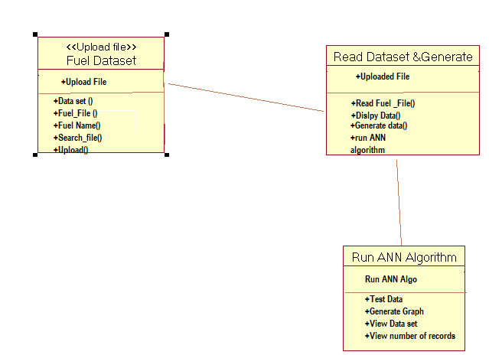

**4.3.2 USE CASE DIAGRAMS**

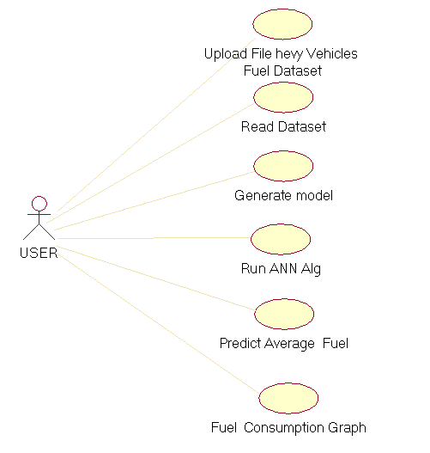

**4.3.3 SEQUANCE DIAGRAMS**

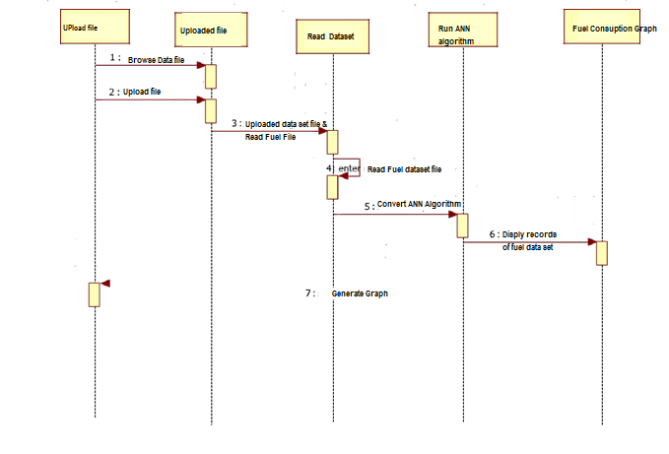

Fig 4.3.3:sequence diagrams

CHAPTER 5

SCREEN SHOTS & CONCLUSION & & REFERENCES

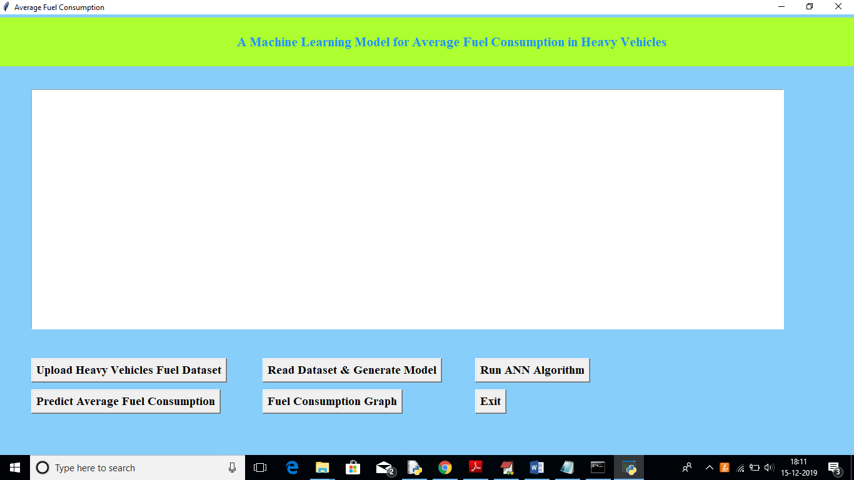

In above screen click on ‘Upload Heavy Vehicles Fuel Dataset’ button to upload train dataset

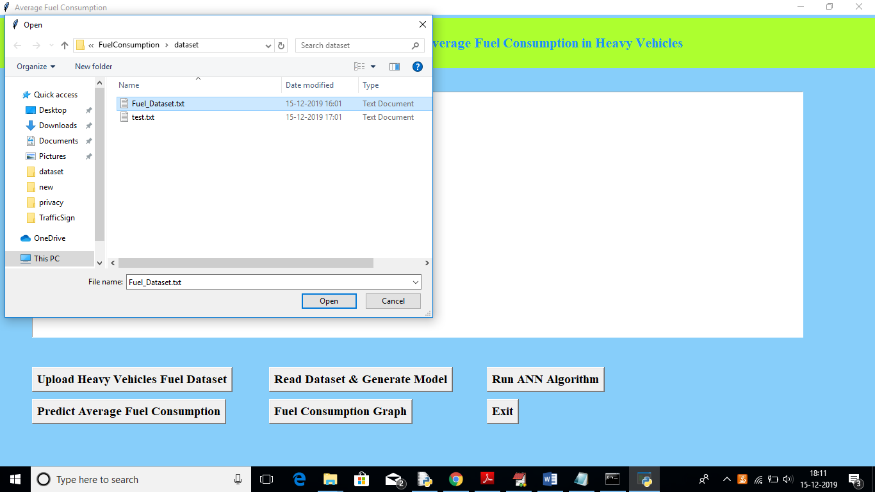

In above screen uploading ‘Fuel_Dataset.txt’ which can be used to train model. After uploading dataset will get below screen

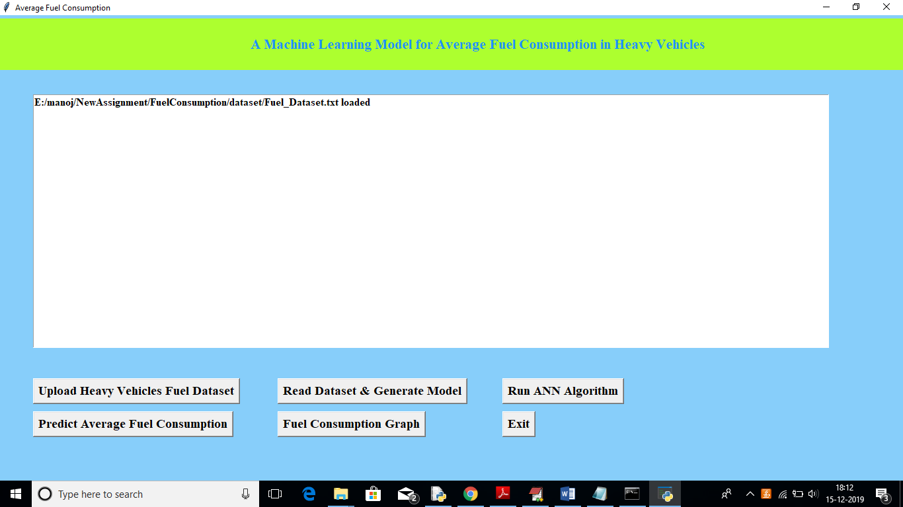

Now in above screen click on ‘Read Dataset & Generate Model’ button to read uploaded dataset and to generate train and test data

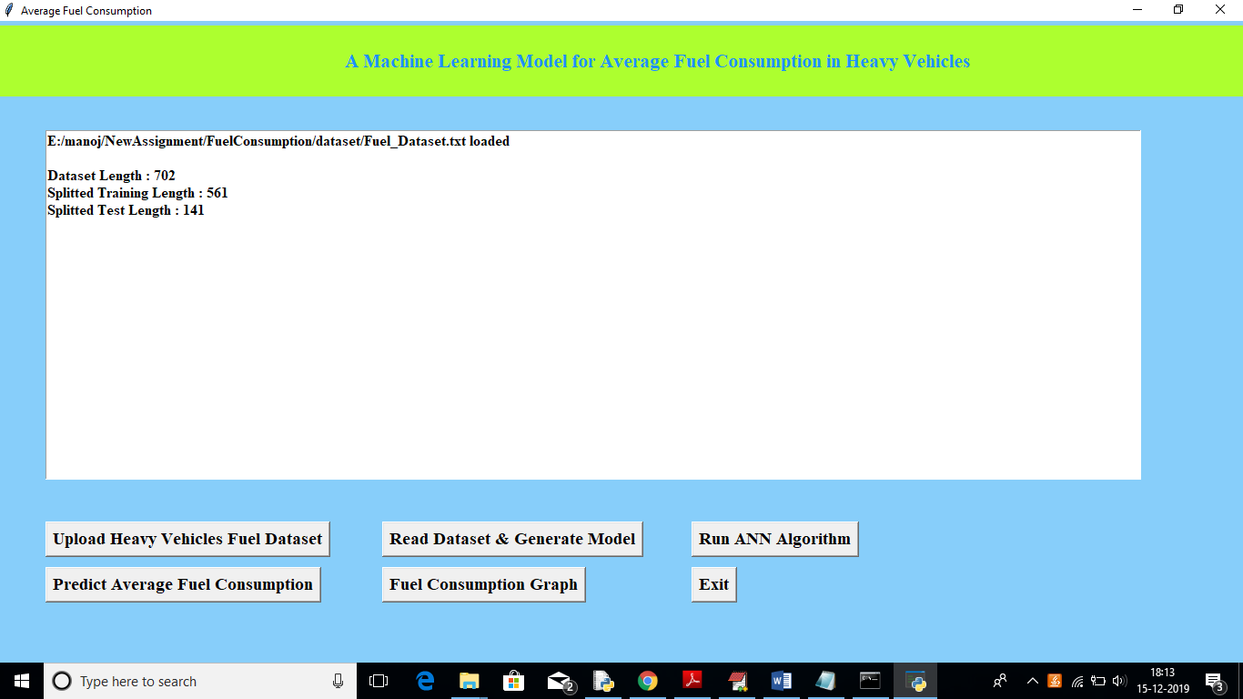

In above screen we can see total number of records in dataset, number of records used for training and number for records used for testing. Now click on ‘Run ANN Algorithm’ button to input train and test data to ANN to build ANN model.

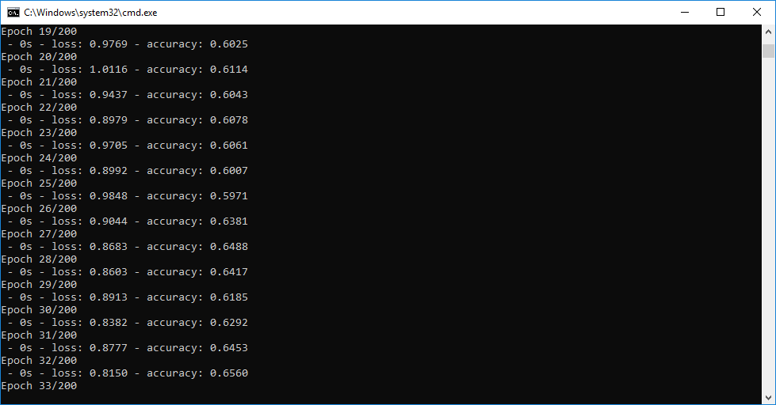

In above black console we can see all ANN processing details, After building model will get below screen

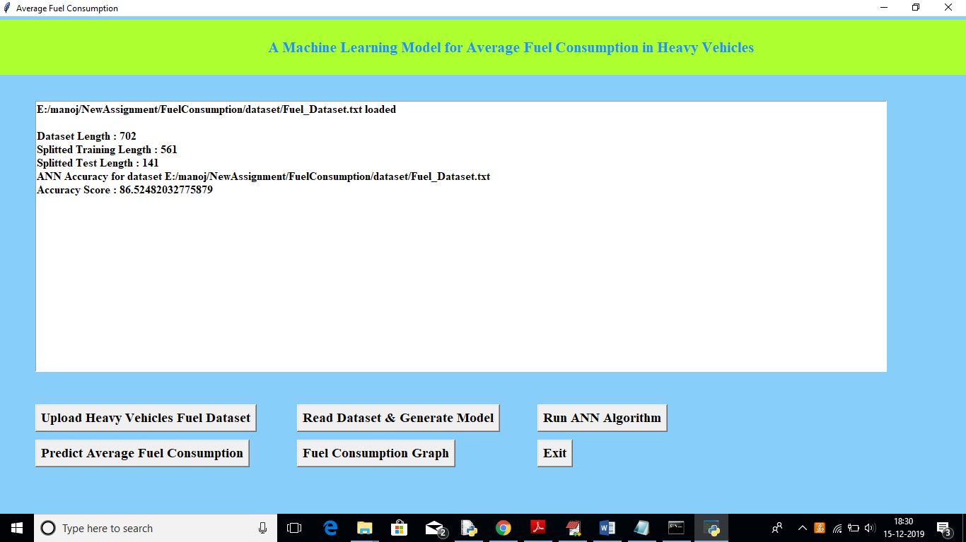

In above screen we got ANN prediction accuracy upto 86%. Now click on ‘Predict Average Fuel Consumption’ button to upload test data and to predict consumption for test data

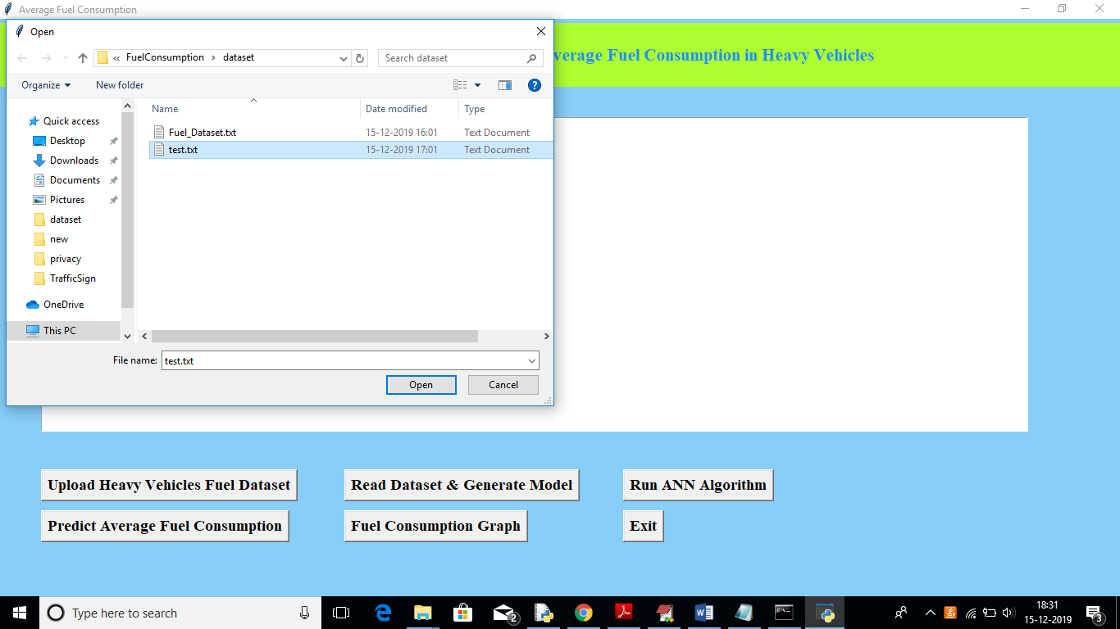

After uploading test data will get fuel consumption prediction result in below screen

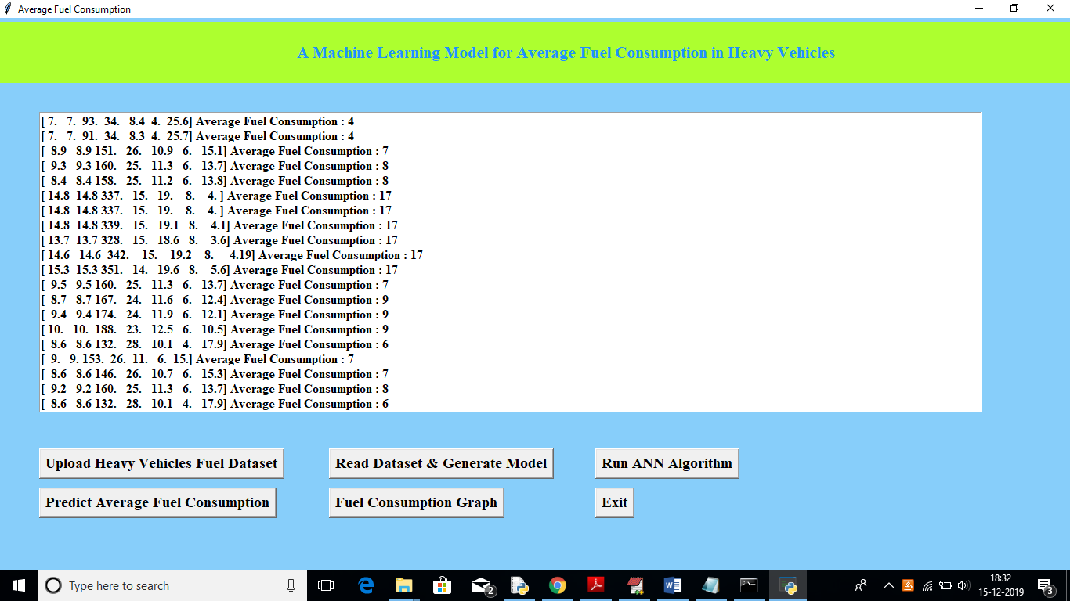

In above screen we got average fuel consumption for each test record per 100 kilo meter. Now click on ‘Fuel Consumption Graph’ to view below graph

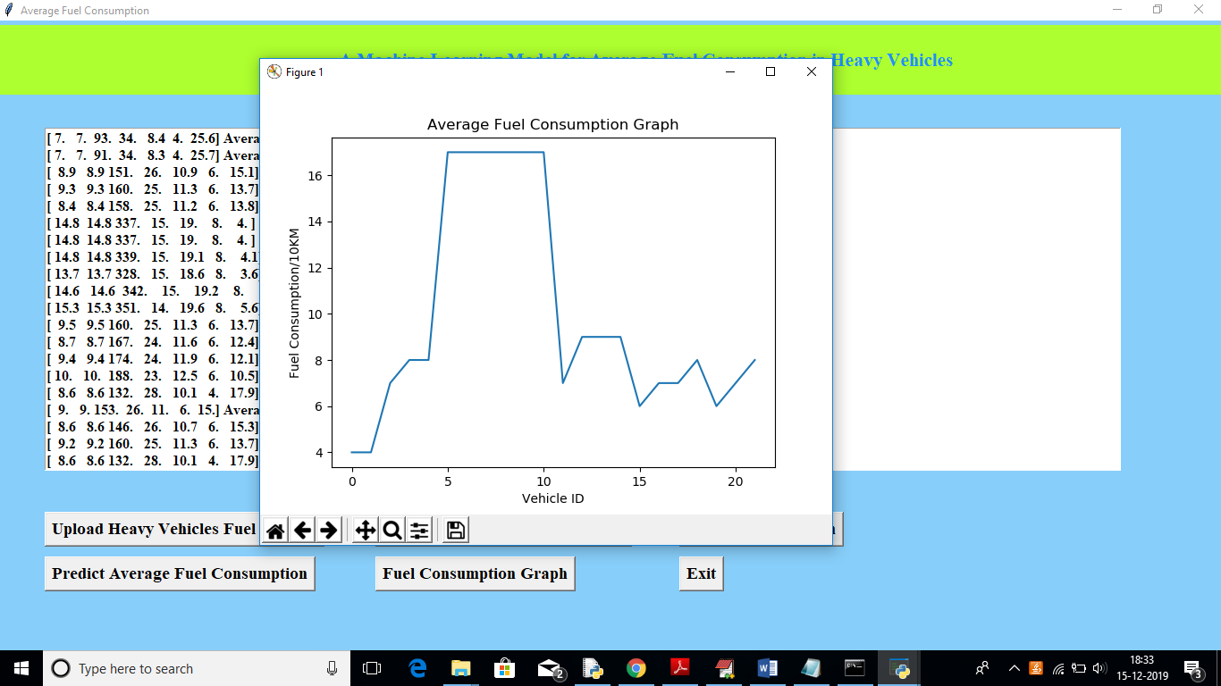

In above graph x-axis represents test record number as vehicle id and y-axis represents fuel consumption for that record.

**CONCLUSION**

machine learning model that can be conveniently developed for each heavy vehicle in a fleet.

The model relies on seven predictors: number of stops, stop time, average moving speed, characteristic acceleration, aerodynamic speed squared, change in kinetic energy and change in potential energy.

The last two predictors are introduced in this paper to help capture the average dynamic behavior of the vehicle. All of the predictors of the model are derived from vehicle speed and road grade.

These variables are readily available from telematics devices that are becoming an integral part of connected vehicles. Moreover, the predictors can be easily computed on-board from these two variables.

**FUTURE SCOPE :**

* Future work also includes investigating the minimum distance required for training each model and analyzing how often does a model need to be synchronized with the physical system in operation by using online training in order to maintain the prediction accuracy of the model.
* predict average fuel consumption in heavy vehicles using Machine Learning Algorithm such as ANN (Artificial Neural Networks). To predict fuel consumption author has extracted 7 predictor features from heavy vehicle dataset such as
* **num_stops, time_stopped, average_moving_speed, characteristic_acceleration, aerodynamic_speed_squared, change_ in_kinetic_energy, change_in_potential_energy, class**